FIDIC Future Leaders Committee

Candidate Nomination Information 2020-2023
To: FIDIC Member Associations
FIDIC Future Leaders Groups of FIDIC member associations

This is a Call for Candidates for the FIDIC Future Leaders Committee for the year 2020-2023. The term of appointment shall be for a fixed period of three (3) years and may be extended by one (1) year by the Board if considered to be in FIDIC’s best interest or if a member advances to chair of the committee.
The FIDIC Future Leaders Committee is looking for new members to participate in the coordination and execution of FIDIC Future Leaders (FL) activities.
The FIDIC Future Leaders Committee (FLC) (“the Committee”) is a working Committee of FIDIC appointed by the FIDIC Board, whose primary functions are to:

• Identify opportunities and promote the interests of Future Leaders to create greater opportunities for them to contribute, develop and succeed within FIDIC, in the industry and towards external stakeholders.
• Create targeted activities for Future Leaders to increase the exposure and opportunities for Future Leaders.
• Advise the FIDIC Board and Secretariat on all aspects of Future Leaders in the Consulting Engineering industry.

The strategic priorities of the Committee are to:

• Plan, advise, promote and coordinate individual and Member Association participation in the FIDIC Future Leaders Management Certificate and Future Leader events at FIDIC conferences, in collaboration with the Secretariat.
• Work with Future Leaders in Regional Groups and Member Associations to identify best practice, trends and activities of interest.
• Work with Future Leaders to prepare white papers for FIDIC on issues of concern to Future Leaders.
• Promote and facilitate Future Leaders, who are members of FIDIC Committees and Task Groups to communicate with Future Leader groups from other organisations to gain and share their insights.
• Support the development of a FIDIC Global Knowledge Platform.
• Initiate, promote and support development of FIDIC’s social media presence and its use of social media technology to enhance cooperation across all stakeholders.
• Collaborate with the World Federation of Engineers to promote the interests of FIDIC Future Leaders.

Background: The FIDIC Future Leaders Group (FLG), formerly Young Professionals Forum (YPF) was established in 2004 at the FIDIC International Conference in Copenhagen. The purpose of the Forum was to encourage the involvement of more young professionals in FIDIC activities. The Forum defined its business plan, clearly setting out its vision, mission, and organization values in 2007 under the leadership of an international Steering Committee. As a leadership committee, the new Future Leaders Committee (FLC) was formed to develop communication and networking opportunities for all FLs involved in the FIDIC community.
New members: The FIDIC Future Leaders Committee is calling for nominations that may be sponsored by FIDIC Member Associations (MAs) and/or groups of future leaders formed under the umbrella of FIDIC Member Associations or Regional groups. Nominations to the committee will be reviewed and interviewed by active FL members. Successful candidates will be notified for appointment from May 2020.
The FIDIC FLC anticipates inviting qualified candidates to join the committee. This number will be identified according to the quality and number of nominated candidates.
We encourage MAs and FL groups within MAs to nominate candidates who are currently active in their FL groups. This allows the candidate to better represent his country and region for the development of ongoing activities undertaken by the FIDIC Future Leaders Committee.
Future Leaders Committee members meet monthly using online platforms like Skype or Zoom. Members are encouraged to attend an annual face to face meeting during the FIDIC International Infrastructure Conference in September.
More information on the FIDIC Future Leaders Group and its committee can be found on the FIDIC website at: https://fidic.org/FLC
Who should apply
Candidates for the Future Leaders Committee should be able and willing to carry out the following activities:
- Participate in monthly online meetings to discuss business and pursue FL goals.
- Dedicate the required time each month to contribute to FL goals and activities.
- Coordinate activities between the FIDIC international FL and national and regional groups.
- Willingness to be interviewed via teleconference by current members of the FLC.
- Provide a short letter of recommendation from their national MA and/or their company.
6. Candidates should be young professionals under the age of 40 years at the time of application. Exceptions will be granted upon the discretion of the FLC.
Candidates will be contacted and interviewed by a current member of FLC. Successful candidates will be duly notified after the interviews.

APPLICATION FOR 2020-2023 FIDIC Future Leaders Committee
Please fill the application below and email your application to the attention of:
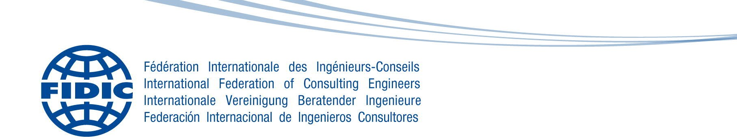
Cosmin Tobolcea, Chair of FIDIC Future Leaders Group
Subject: Application for FIDIC FLC, at: ocohen@fidic.org and cosmin.tobolcea@protoby.ro
1. Name (First name and Last name)
2.Nationality
3. Country of Work:
4.Position in your company
5. Age (DOB)
6. Email:
7. Organization/Company
8. Contact details (including mailing address, email, Skype)
9. Phone/ Mobile
10. Please provide your views for the development of the FIDIC Future Leaders Group.
For example:
-Why do you want to join the FIDIC Future Leaders Committee?
-What do you want to do?
-How will you contribute to the FLC?
11. Experience in FIDIC
12. Experience in a FIDIC related organization
13. Experience within your Member Association FL/YPs group, or another professional society in your country
14. Additional comments/requests
15. Identify the best time/dates for a FIDIC Future Leaders Committee member to contact you. Please also provide your time zone relative to GMT.
Note: Please make sure to attach a letter of recommendation from your national Member Association and company.

